False Positive and False Negative

1-True Positive

What is True Positive
# Source: AI Source: Provided by: [Data Path: Persons Table -> ID Column: 1, Name_En Column: Motasem Essam] -> From: [Chatgpt (GPT‑5 Mini)] on [8/22/2025]
A True Positive in software testing refers to a situation where the test correctly identifies a real defect or issue in the system. It is an accurate detection of a problem.

✅ Key Points
# Source: AI Source: Provided by: [Data Path: Persons Table -> ID Column: 1, Name_En Column: Motasem Essam] -> From: [Chatgpt (GPT‑5 Mini)] on [8/22/2025]
- Indicates a real defect exists and the test flagged it correctly.
- Represents the desired outcome for defect detection.
- Opposite of a False Positive.

✅ Examples
# Source: AI Source: Provided by: [Data Path: Persons Table -> ID Column: 1, Name_En Column: Motasem Essam] -> From: [Chatgpt (GPT‑5 Mini)] on [8/22/2025]
- A security scanner detects an actual SQL Injection vulnerability.
- A unit test fails because the application logic is genuinely incorrect.
- An automated functional test catches an error in form validation when invalid input is provided.

✅ Why It’s Important
# Source: AI Source: Provided by: [Data Path: Persons Table -> ID Column: 1, Name_En Column: Motasem Essam] -> From: [Chatgpt (GPT‑5 Mini)] on [8/22/2025]
- Helps ensure that defects are found early and fixed before release.
- Increases trust in the testing process and tools.

2-True Negative

What is True Negative
# Source: AI Source: Provided by: [Data Path: Persons Table -> ID Column: 1, Name_En Column: Motasem Essam] -> From: [Chatgpt (GPT‑5 Mini)] on [8/22/2025]
A True Negative in software testing refers to a situation where the test correctly identifies that there is no defect, meaning the system works as expected and the test passes.

✅ Key Points
# Source: AI Source: Provided by: [Data Path: Persons Table -> ID Column: 1, Name_En Column: Motasem Essam] -> From: [Chatgpt (GPT‑5 Mini)] on [8/22/2025]
- Indicates the system is functioning correctly, and the test confirms it.
- Opposite of False Negative.
- Represents the ideal outcome for scenarios without issues.

✅ Examples
# Source: AI Source: Provided by: [Data Path: Persons Table -> ID Column: 1, Name_En Column: Motasem Essam] -> From: [Chatgpt (GPT‑5 Mini)] on [8/22/2025]
- A login test with valid credentials passes successfully (no defect present).
- A security scan confirms no SQL Injection vulnerability in a properly coded input field.
- A functional test on a feature that works correctly reports Pass.

✅ Why It’s Important
# Source: AI Source: Provided by: [Data Path: Persons Table -> ID Column: 1, Name_En Column: Motasem Essam] -> From: [Chatgpt (GPT‑5 Mini)] on [8/22/2025]
- Confirms system stability for scenarios with no defects.
- Builds confidence in the accuracy of testing.

3-False Positive

What is False Positive
# Source: AI Source: Provided by: [Data Path: Persons Table -> ID Column: 1, Name_En Column: Motasem Essam] -> From: [Chatgpt (GPT‑5 Mini)] on [8/22/2025]
A False Positive in software testing refers to a situation where a test incorrectly reports a defect or failure when the system is actually working correctly.

✅ Key Points
# Source: AI Source: Provided by: [Data Path: Persons Table -> ID Column: 1, Name_En Column: Motasem Essam] -> From: [Chatgpt (GPT‑5 Mini)] on [8/22/2025]
- It is an incorrect indication of a problem.
- Happens when the test case or testing tool flags an issue that does not exist.
- Common in automation testing, static code analysis, and security scans.

✅ Causes
# Source: AI Source: Provided by: [Data Path: Persons Table -> ID Column: 1, Name_En Column: Motasem Essam] -> From: [Chatgpt (GPT‑5 Mini)] on [8/22/2025]
- Incorrect Test Scripts: Automation scripts not updated for recent changes.
- Misconfigured Testing Tools: Tools set with wrong rules or thresholds.
- Environment Issues: Test environment not mirroring production properly.
- Outdated Test Data: Tests running against old or irrelevant data.

✅ Examples
# Source: AI Source: Provided by: [Data Path: Persons Table -> ID Column: 1, Name_En Column: Motasem Essam] -> From: [Chatgpt (GPT‑5 Mini)] on [8/22/2025]
- A security scanner reports SQL Injection vulnerability, but input validation is properly implemented.
- An automated UI test fails because of minor UI element position changes, even though functionality works fine.
- A static code analysis tool flags a safe function call as a potential risk.

✅ Impact
# Source: AI Source: Provided by: [Data Path: Persons Table -> ID Column: 1, Name_En Column: Motasem Essam] -> From: [Chatgpt (GPT‑5 Mini)] on [8/22/2025]
- Wastes time investigating non-existent issues.
- Increases testing effort and may delay releases.
- Can reduce trust in testing tools if frequent.

4-False Negative

What is False Negative
# Source: AI Source: Provided by: [Data Path: Persons Table -> ID Column: 1, Name_En Column: Motasem Essam] -> From: [Chatgpt (GPT‑5 Mini)] on [8/22/2025]
A False Negative in software testing refers to a situation where a test fails to detect an existing defect or issue, incorrectly indicating that everything is working fine.

✅ Key Points
# Source: AI Source: Provided by: [Data Path: Persons Table -> ID Column: 1, Name_En Column: Motasem Essam] -> From: [Chatgpt (GPT‑5 Mini)] on [8/22/2025]
- Opposite of False Positive.
- Means the test result is “Pass” when there is actually a defect.
- Dangerous because defects remain undetected and can reach production.

✅ Causes
# Source: AI Source: Provided by: [Data Path: Persons Table -> ID Column: 1, Name_En Column: Motasem Essam] -> From: [Chatgpt (GPT‑5 Mini)] on [8/22/2025]
- Poor Test Coverage: Important scenarios not included in test cases.
- Incorrect Test Logic: Test script does not check the right conditions.
- Tool Limitations: Automated tools failing to detect certain vulnerabilities.
- Incomplete Requirements Understanding: Missing conditions during test design.

✅ Examples
# Source: AI Source: Provided by: [Data Path: Persons Table -> ID Column: 1, Name_En Column: Motasem Essam] -> From: [Chatgpt (GPT‑5 Mini)] on [8/22/2025]
- An automated test reports a “Pass” even though a calculation in the code is incorrect.
- A security scan fails to detect an actual XSS vulnerability.
- A unit test checks only positive scenarios, ignoring edge cases where errors occur.

✅ Impact
# Source: AI Source: Provided by: [Data Path: Persons Table -> ID Column: 1, Name_En Column: Motasem Essam] -> From: [Chatgpt (GPT‑5 Mini)] on [8/22/2025]
- Critical defects go undetected, causing failures in production.
- Can lead to security breaches, financial loss, or system crashes.

Summary Table
# Source: AI Source: Provided by: [Data Path: Persons Table -> ID Column: 1, Name_En Column: Motasem Essam] -> From: [Chatgpt (GPT‑5 Mini)] on [8/22/2025]
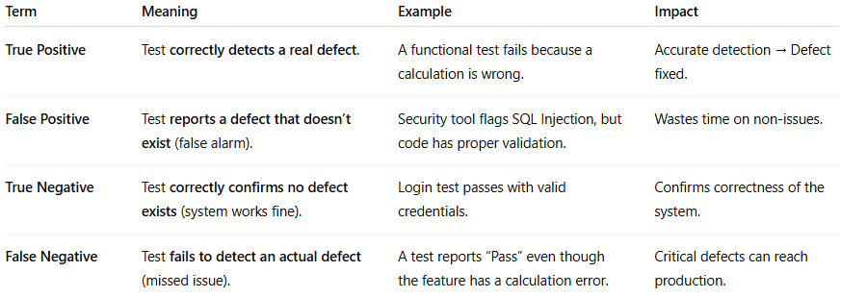

Term | Meaning | Example | Impact
True Positive | Test correctly detects a real defect. | A functional test fails because a calculation is wrong. | Accurate detection → Defect fixed.
False Positive | Test reports a defect that doesn’t exist (false alarm). | Security tool flags SQL Injection, but code has proper validation. | Wastes time on non-issues.
True Negative | Test correctly confirms no defect exists (system works fine). | Login test passes with valid credentials. | Confirms correctness of the system.
False Negative | Test fails to detect an actual defect (missed issue). | A test reports “Pass” even though the feature has a calculation error. | Critical defects can reach production.

